DS 584 – Cloud Computing
Assignment 01 – Milestone 04: Synthetic Workload Generation
University of the Punjab, Lahore

1. Objective
This milestone generates synthetic HTTP workload against the Nginx reverse-proxy/load-balancer using httperf, records the resulting response-time behaviour, and profiles CPU utilization of the proxy VM during the experiment. Two deliverable graphs are produced: (1) average response time versus offered request load, and (2) CPU utilization of the proxy VM over the course of the test.

2. Test Environment
- Nginx load-balancer VM: 192.168.98.12 (routes /api/solve to two backend app VMs)
- Application VM 1: 192.168.98.11
- Application VM 2: 192.168.98.10
- httperf load-generator VM: 192.168.98.14
- Host machine: macOS (VMware Fusion), monitored in parallel as MacBook.csv
Each VM was provisioned with 2 GB RAM and 2 vCPUs. Nginx was configured to distribute incoming requests across the two application VMs using its default round-robin balancing.

3. Workload Generation Method
httperf was run from the dedicated load-generator VM against the Nginx VM's public endpoint. A representative invocation:
httperf --server=192.168.98.12 --port=80 --uri=/api/solve --num-conns=40000 --num-calls=1 --rate=<RATE> --timeout=5
The --rate value (offered requests per second) was swept from 400 req/s up to 60,000 req/s across six benchmark batches, with light loads (400–600 req/s) repeated 3 times each to reduce noise, and heavier loads run once each because the system's behaviour there was already saturated and highly repeatable. For every run, httperf's summary output (connection rate, response time, reply rate, CPU time, and error breakdown) was parsed into a benchmark_results.csv row.

4. CPU Profiling Utility
A lightweight Python profiler (using psutil) sampled system-wide CPU utilization, per-core peak CPU, memory, and network throughput once per second on each VM and on the host machine, writing a timestamped CSV row per sample. This was run continuously, in parallel with httperf, for the full duration of the benchmark sweep so that the CPU trace could later be aligned against the load-test timeline. A minimal reference implementation of this utility:
import csv, time, socket, datetime
import psutil

HOSTNAME = socket.gethostname()
OUTFILE = "cpu_profile.csv"

FIELDS = ["timestamp_utc","elapsed_s","hostname","cpu_percent",
"cpu_peak_core_percent","memory_percent","memory_used_mib",
"net_sent_kib_s","net_recv_kib_s"]

def sample(start_time, prev_net):
now = datetime.datetime.utcnow()
cpu = psutil.cpu_percent(interval=1)
per_core = psutil.cpu_percent(interval=None, percpu=True)
mem = psutil.virtual_memory()
net = psutil.net_io_counters()
sent_kib = (net.bytes_sent - prev_net.bytes_sent) / 1024.0
recv_kib = (net.bytes_recv - prev_net.bytes_recv) / 1024.0
row = [now.isoformat(), round(time.time() - start_time, 3), HOSTNAME,
cpu, max(per_core) if per_core else 0, mem.percent,
round(mem.used / (1024*1024), 2), round(sent_kib, 2), round(recv_kib, 2)]
return row, net

if __name__ == "__main__":
start = time.time()
prev_net = psutil.net_io_counters()
with open(OUTFILE, "w", newline="") as f:
writer = csv.writer(f)
writer.writerow(FIELDS)
try:
while True:
row, prev_net = sample(start, prev_net)
writer.writerow(row)
f.flush()
except KeyboardInterrupt:
pass

5. Results

5.1 Response Time vs. Offered Request Load
Figure 1 plots the average response time (from httperf's "Reply time [ms]: response" field) against the offered request rate, averaged across repeats at each load level.
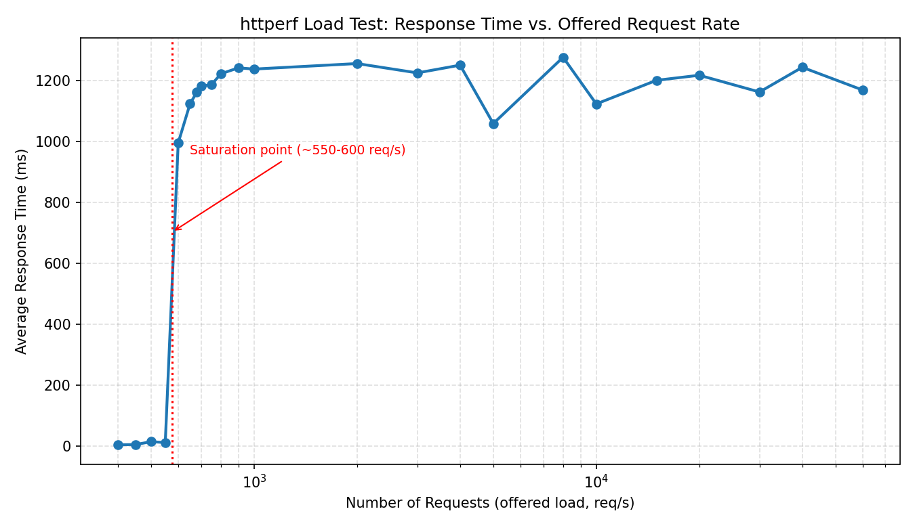
Figure 1. Average response time rises sharply once offered load passes ~550-600 req/s, then plateaus around 1.0-1.3 seconds as the system saturates.

5.2 CPU Utilization of the Nginx Proxy VM
Figure 2 plots CPU utilization of the Nginx load-balancer VM (192.168.98.12) sampled every second for the full ~42-minute test session, covering every load level in sequence with idle cooldown gaps between runs.
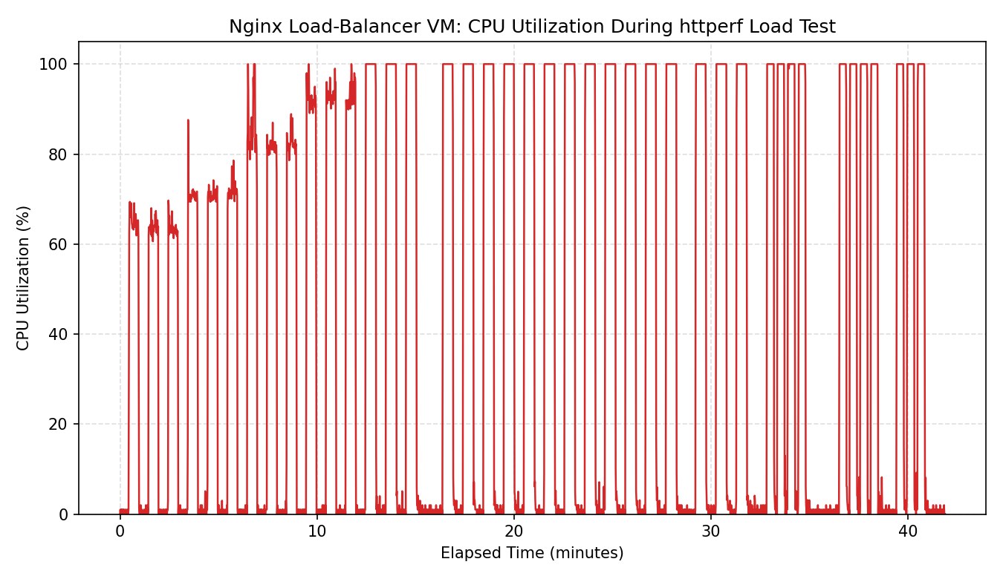
Figure 2. CPU utilization climbs with each successive load level and pins at 100% once the offered rate exceeds the saturation point, matching the response-time knee in Figure 1.

5.3 Summary Data Table
Averaged results per offered load level (full per-run data is in the accompanying combined_benchmark.csv):
Rate (req/s) | Avg Response Time (ms) | Requests Sent | Success Rate (%)
400 | 4.5 | 12000 | 100.0
450 | 5.2 | 13500 | 100.0
500 | 14.7 | 15000 | 100.0
550 | 11.8 | 16500 | 100.0
600 | 996.0 | 15910 | 84.8
650 | 1124.9 | 15967 | 77.7
680 | 1162.1 | 15912 | 73.6
700 | 1182.9 | 15873 | 71.4
750 | 1186.5 | 16084 | 67.4
800 | 1222.9 | 15854 | 62.2
900 | 1242.3 | 15917 | 55.2
1000 | 1238.3 | 15943 | 49.8
2000 | 1256.4 | 10842 | 25.2
3000 | 1225.7 | 10988 | 16.9
4000 | 1251.2 | 11137 | 12.8
5000 | 1059.3 | 12427 | 11.6
8000 | 1277.0 | 11167 | 6.1
10000 | 1123.8 | 12926 | 5.8
15000 | 1201.4 | 11289 | 3.4
20000 | 1218.0 | 11245 | 2.6
30000 | 1163.0 | 11509 | 1.8
40000 | 1244.1 | 11648 | 1.3
60000 | 1169.6 | 12087 | 0.9

6. Analysis
- Below ~550 req/s, the system is not the bottleneck: response time stays in single-digit to low-double-digit milliseconds and success rate is 100%.
- Between 550 and 600 req/s the system hits a saturation knee: response time jumps roughly 100x (from ~12 ms to ~1000 ms) and success rate begins falling.
- Beyond 600 req/s, response time plateaus around 1.0-1.3 s regardless of how much higher the offered rate is pushed — a classic saturated-queue signature: the backend/proxy pipeline is processing at a roughly constant maximum throughput, and any load offered above that just increases the fraction of connections that time out (visible as falling success_pct and rising fd_unavailable errors in the raw CSVs).
- CPU utilization on the Nginx VM confirms this: it climbs with each load step and pins at 100% exactly where response time plateaus, indicating the proxy VM's CPU is the limiting resource at high load.

7. Conclusion
The synthetic workload experiment identified the system's practical capacity at roughly 550-600 requests/second under this VM configuration (2 vCPU / 2 GB RAM per node). Beyond that point, added load only degrades user-facing latency and success rate without increasing throughput, because the Nginx proxy VM's CPU is fully saturated. This gives a concrete capacity figure that could guide horizontal scaling (adding backend VMs) or vertical scaling (more vCPUs on the proxy) decisions.

